**User Guide**

## Getting Started

In order to run the project, you will need to clone the repository from Github (link posted above). You may have to make sure you have Git installed for this, and the following link can help you clone the repository: <https://docs.github.com/en/repositories/creating-and-managing-repositories/cloning-a-repository>

Once you have the code, you will need to do a few things before your project can run. First, you’ll need to run “npm install” in both the frontend and backend projects. This will allow all of the node modules and dependencies to download for the project. You may need to install a few packages that have been globally installed – Typescript, Nodemon, Node, and Yarn are some of these packages. To do this, you’ll need to run “npm install -g typescript.” There may be other global packages you are missing, look at the console and download them as needed, it should tell you exactly what packages it wants, however, most should be included with the first install.

Next, you’ll need to create environment files in both the frontend and the backend. Create a file in both those locations called “.env” and in it, including the following:

* + Frontend
    - NODE_ENV=development
  + Backend
    - NODE_ENV=development
    - ATLAS_URI = *hidden for security reasons*

This will create the connection you need for the database so you can start making changes to the data. Once that is configured, you should be ready to start the project. In the backend, open two terminals and run “yarn watch” to pick up any changes that might be made, and run “yarn dev” in the other one to start the server. In the frontend, run “npm start” to load up the frontend. The project should be up and running.

Please note, this environment is for development purposes only, at the moment. When the product is ready to release in a production environment, it will be deployed so all the user will have to do is go to a URL. We do not have that setup at this moment, as we will address in further sections, but this is how you can get the project started locally to see what it is like.

## Logging in and Registering

If this is your first time using the application, you can start by registering an account. You will be asked to enter in an email, which will be unique and there can only be one email per user, your first name, last name, and a password. There are some checks here to make sure emails are valid and passwords are sufficient. Passwords must be 6 characters long, have an uppercase letter, a lower case letter must have one number, and must have a special character. If the email is free to use and the password meets all of the criteria, you will be navigated to the homepage. You’ll see in the screenshot below, the page will let you know what the requirements are for password and email should you forget

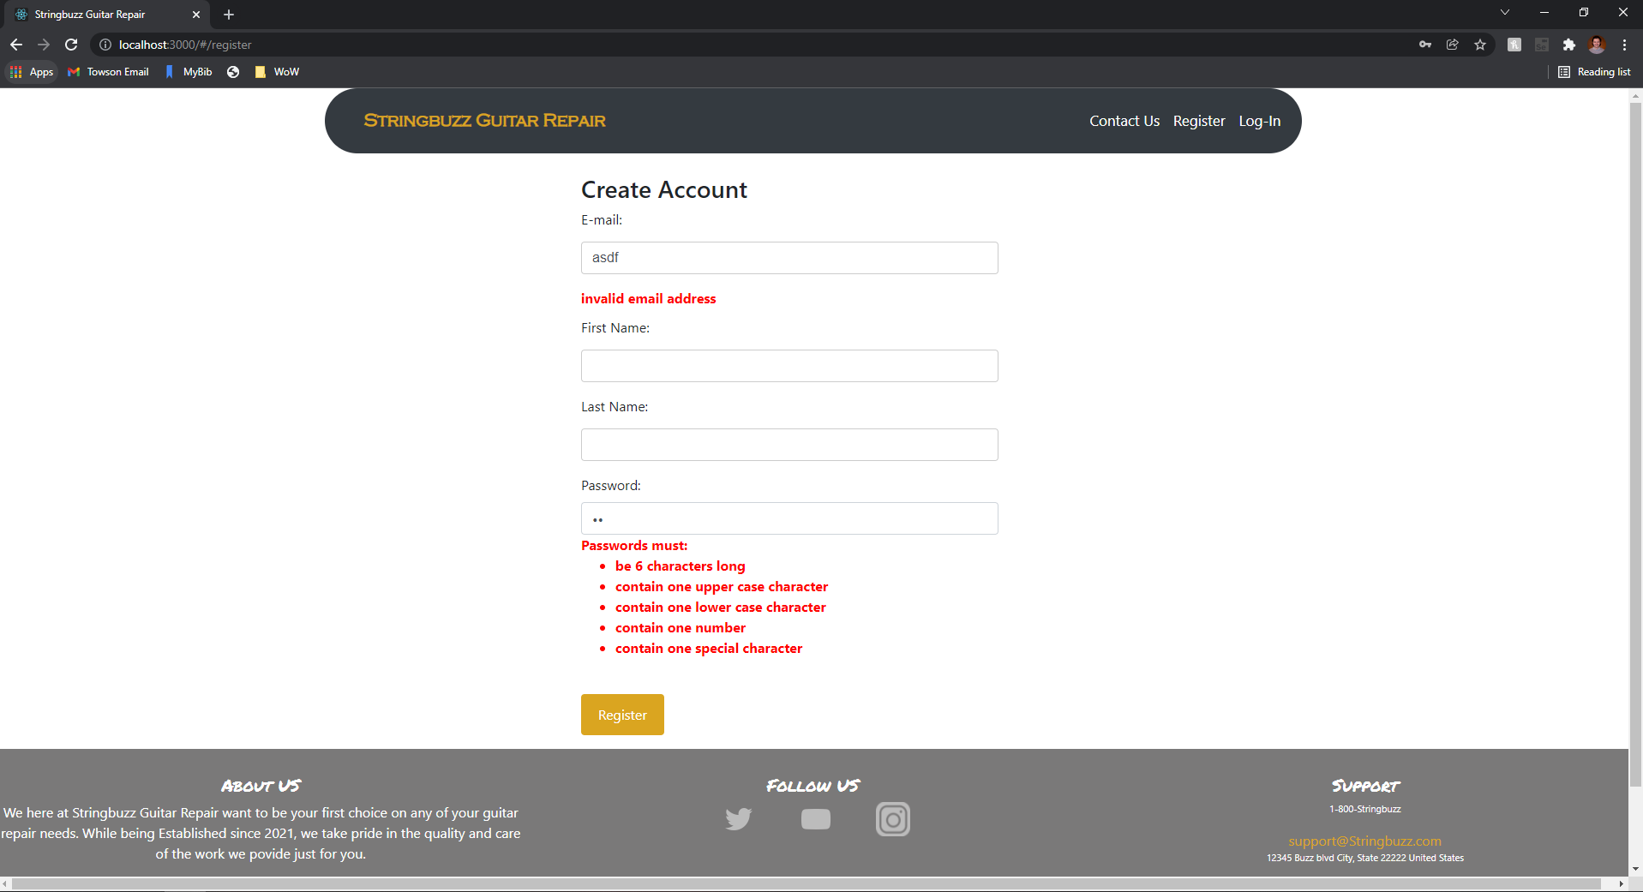

If you are a returning user, you can login rather than register for a new account. Just enter the email address and password and, if your credentials are correct, you will be taken to the homepage.

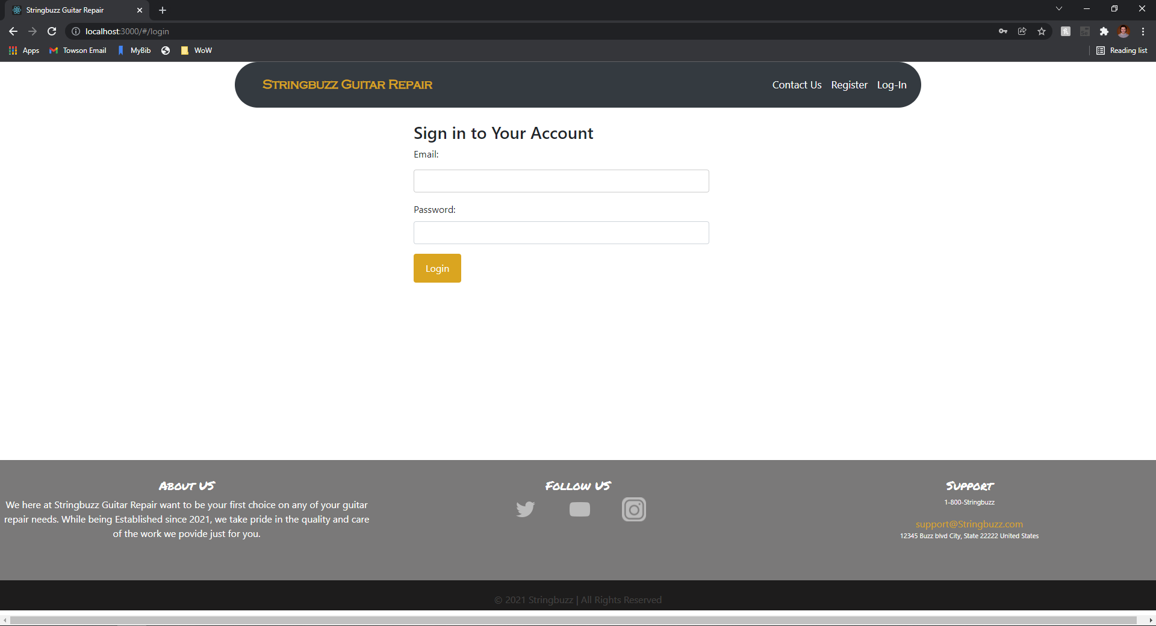

## Homepage

From the homepage, you’ll have a couple of different options. You’ll notice that the navbar changes and you now have links to go to the homepage, go to a “contact us” page, and some options for your account. You’ll have buttons in the middle of the screen to view instruments, make an appointment with the shop, and view repair data. The bottom of the page has a footer with some brief information about the shop, social media links, and the shop's address. Clicking most of these links will take you to other pages and we will hit on those in further sections. Lastly, if you are an admin user you’ll notice that there is a search bar in the navigation bar to search for repairs, users who are customers will not see this. We are still working on the search implementation, but the UI represents what the process could look like.

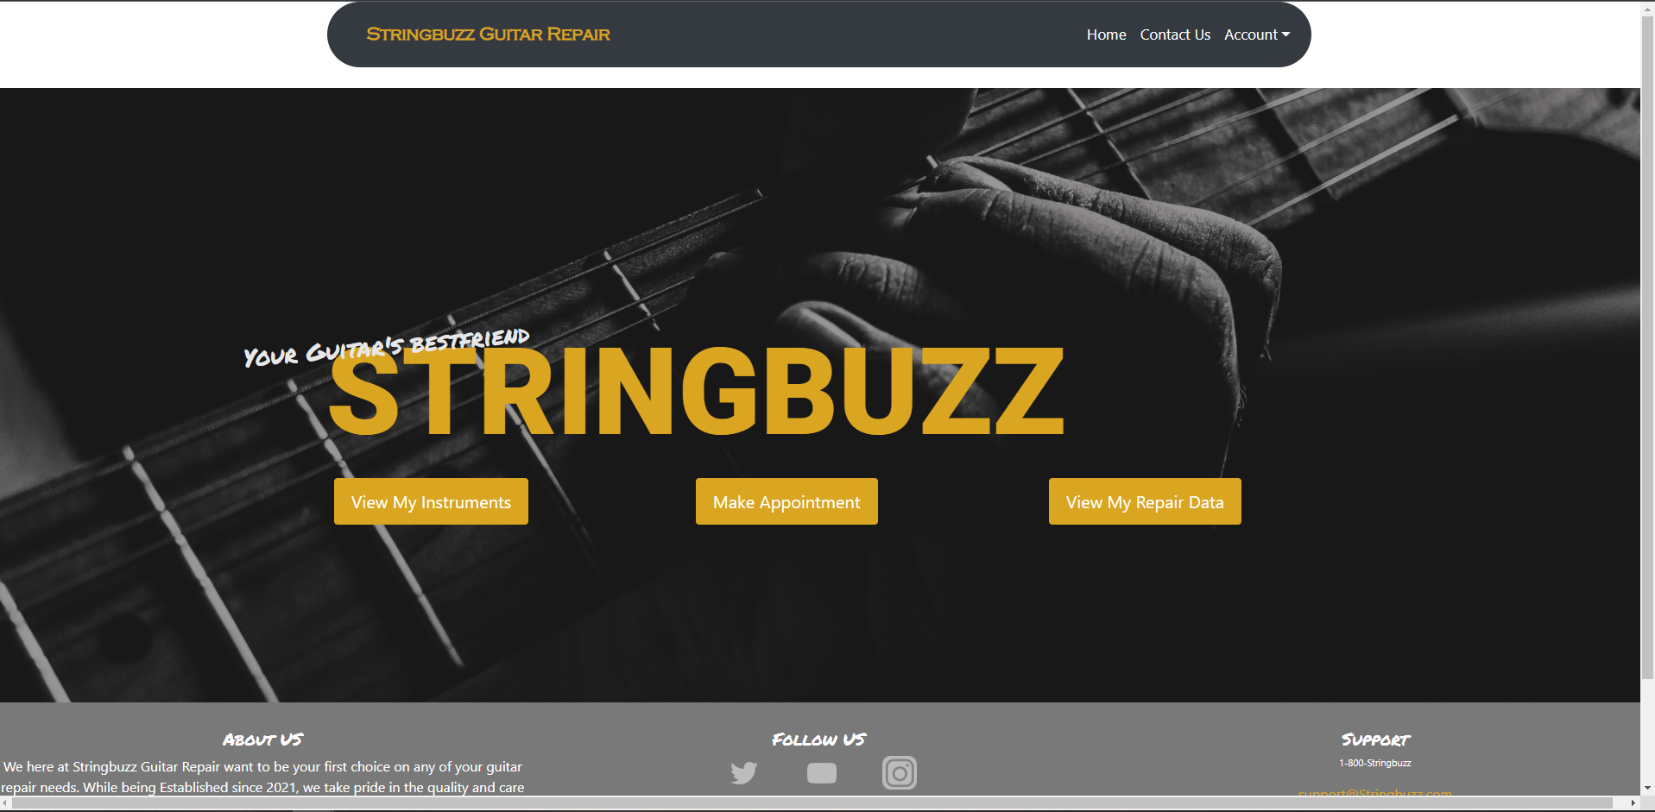

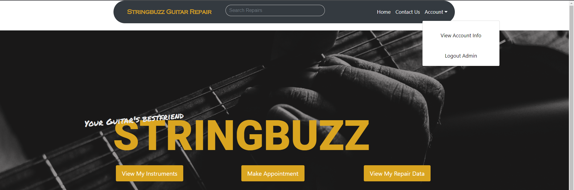

To log out, at any time you can click the “Account” link at the top to open a dropdown and select “Logout.” Also, take note in the screenshot above that the search bar is visible for this admin user.

## Register instrument with the shop

To register an instrument with the shop, click the “View My Instruments” button on the homepage. You’ll then be taken to a different screen and you’ll likely not have any instruments with the shop yet. Click on the “Add Instrument” button at the top right of the page to open up a modal and enter in your instrument information. You’ll need to include a picture, a year, and a serial number that can be used to uniquely identify your instrument. Once the information has been entered in, click on “Add Instrument” at the bottom of the modal and you’ll see your instrument appear on the screen! If you’d like, you can delete the instrument after confirming you’re sure you’d like to do that. In the future, you’ll be able to update details for existing instruments.

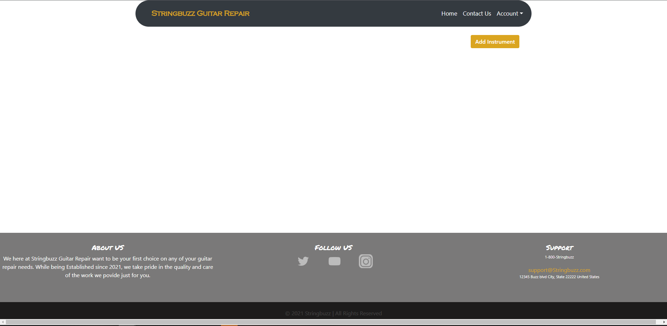

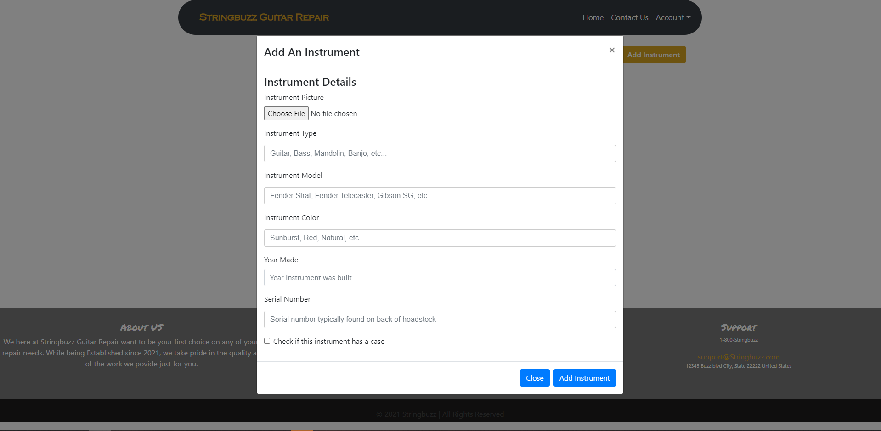

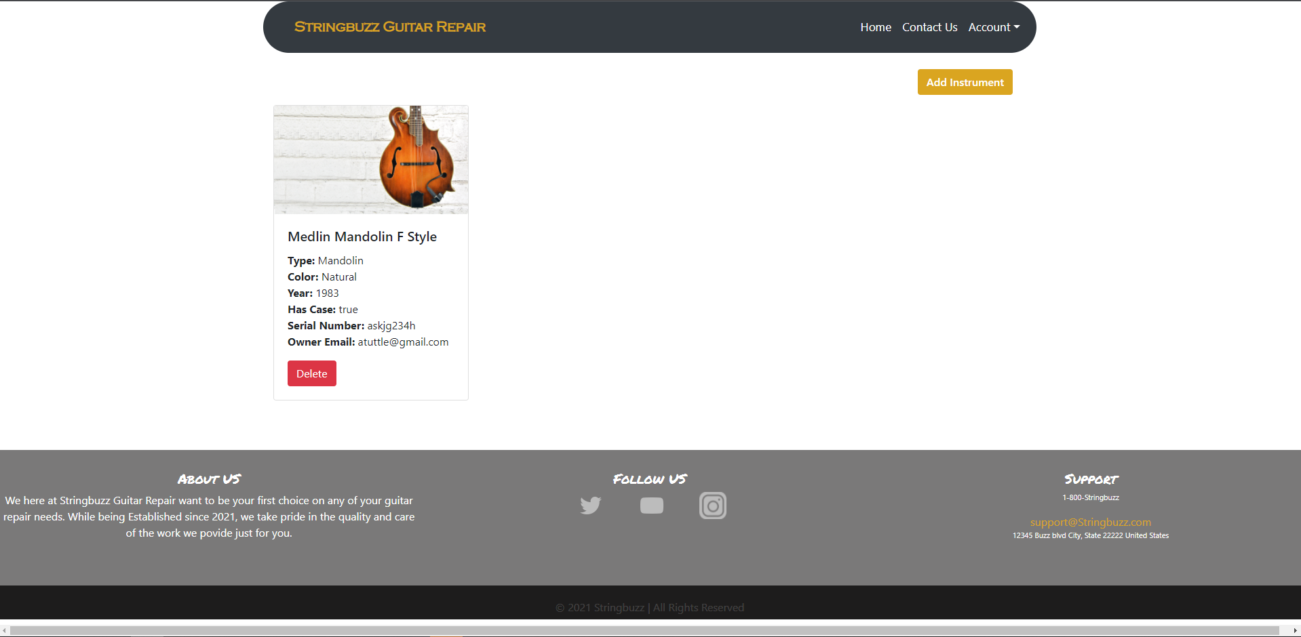

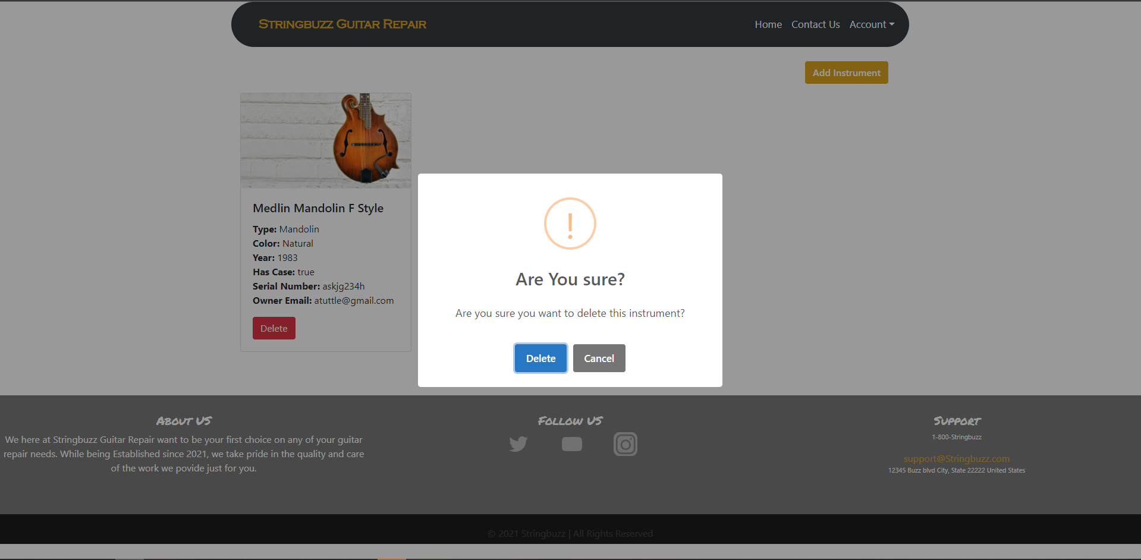

## Contact Us

If you click the “Contact Us” link on the navigation bar, you’ll be directed to a page where you can leave the Stringbuzz Team a message. Just enter in your first name, last name, your email address, and tell the team what’s on your mind! Once the email has been sent, the page will let you know that it was successfully emailed. The Stringbuzz team can view the email in their google account.

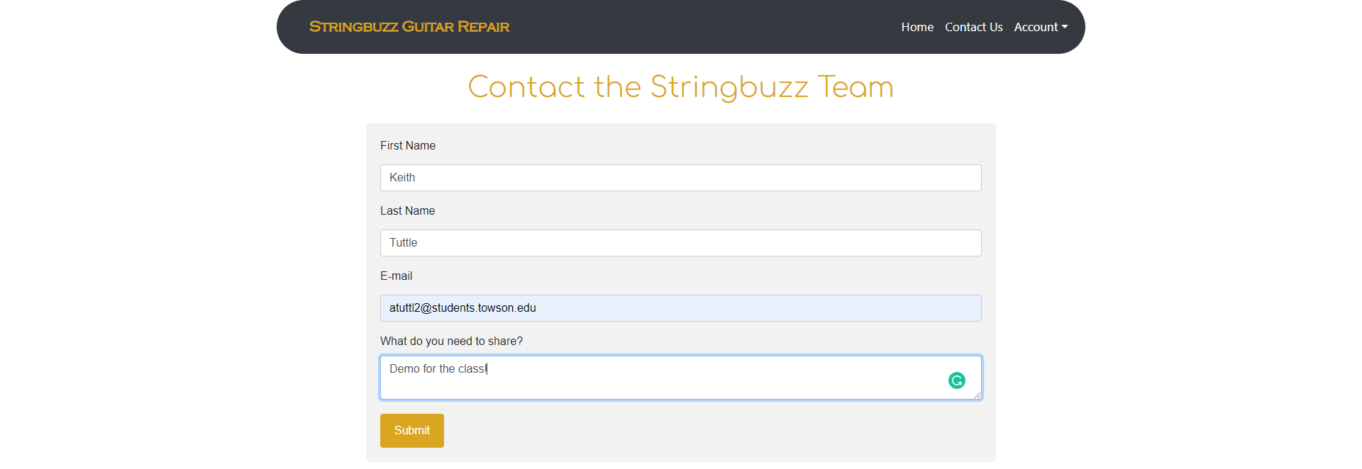

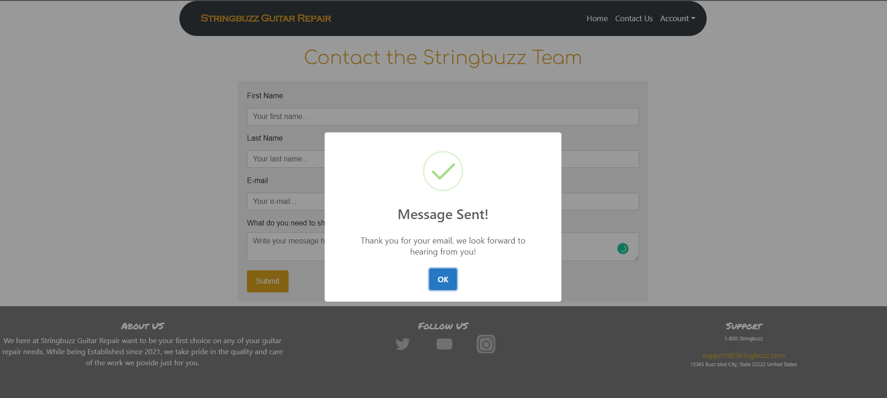

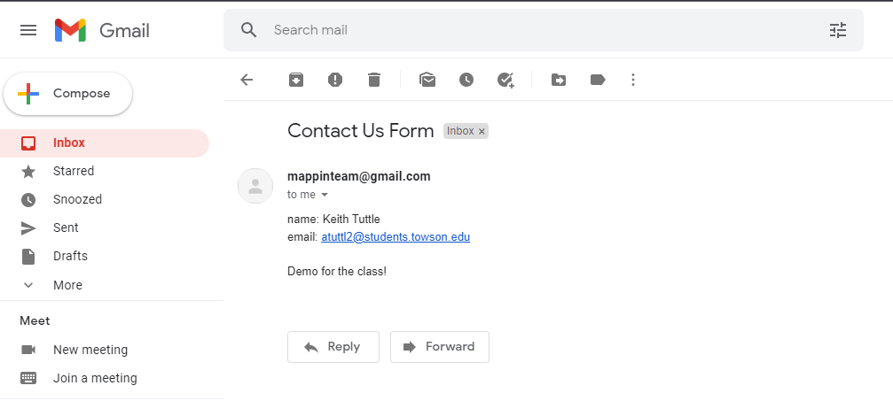

## Features to come and in development

We are currently working on the other features and buttons and, for the time being, there are placeholders there so the buttons will navigate to a dedicated screen for each use case. Here are some of the screens we have, waiting for future implementation.

Clicking the “View Account Info” in the account dropdown, the “Make Appointment” button on the homepage, and the “View My Repair Data” button will take you to screens much like this one:



We look forward to building out these features and finishing the project in the weeks to come!